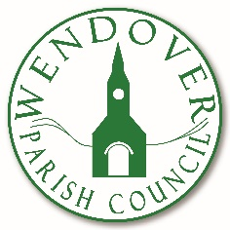
Tel: 01296 623 056 Follow us on Facebook
www.wendover-pc.gov.uk @wendoverparish

Wendover Parish Council
Coronation Window Decoration Competition
Wendover Parish Council are inviting businesses in Wendover to enter into our window competition, to celebrate the Coronation of His Majesty The King and Her Majesty The Queen Consort. With the 1st place window winning a voucher worth £50, so get the bunting out and enter below!
Business Name *

Business Address

Contact Name *

Contact Email Address *

Contact Phone Number

Terms and Conditions -
To participate and be in the running to win the £50 prize you need to send a completed entry form to estates@wendover-pc.gov.uk before Friday 28th April 2023. Judges decision is final, and the winner will be contacted after the 9th of May 2023.
I agree to the terms and conditions (sign here) __________________________

